Module-3

**Fair Labour Practices**

|  |  |
| --- | --- |
| Session-1 | International Labour Standards (ILS) and national Laws |
| Session-2 | Child Labour prevention and youth education |
| Session-3 | Fair wages, safe working conditions, and social protection |

**Introduction**

As the sessions are very technical, each session to be explained in very understandable manner, keeping the education level of the trainees.

**Fair labour Practices**

In workplace it is important to have fair labour practices to foster a health, equitable and inclusive environment. Along with the employee welfare it also increases the productivity, improves morale and over all job satisfaction.

The fair labour practices refer to policies and actions that upholds workers rights, and ensure equitable treatment, and promote safe, healthy and respectful work environment. These practices are such as fair wages, reasonable working hours, non-discriminatory hiring practices and workplace safety.

**Session-1**

**International Labour Standards (ILS) and National Laws**

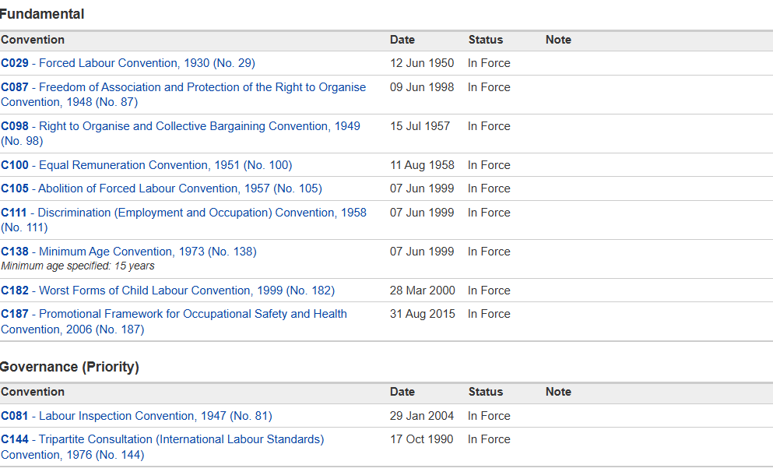

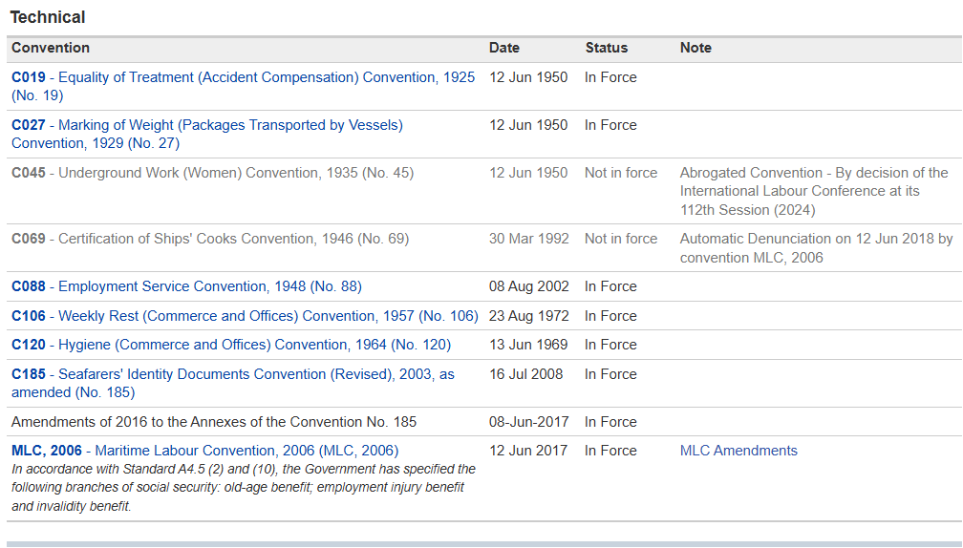

**National Labour Laws**

13 of 2003 Concerning Manpower. The prevailing Indonesian labor laws reflect anti-discrimination principles.each employee shall have equal opportunity without discrimination to obtain work and shall be entitled to equal treatment from the employer without discrimination  (Articles 5 and 6 of the Labor Law).Most provinces in Indonesia have determined and announced their respective minimum wage increases for 2025. Below are the updated figures:  DKI Jakarta: Rp5,067,381-Rp 5,396,760. West Java: Rp2,057,495 → Rp2,191,232.

**Working conditions:**

The poor working conditions are characterised by the absence of labour rights, long working hours, unstable and low earnings, the absence of formally-recognised worker unions, risks to workers' safety, limited access to accident and health insurance, as well as varied gendered challenges for female workers.

**Session- 2**

**Child Labour Prevention and youth education**

**Manpower act of Indonesia**

The Manpower Act is one of the three important pieces of legislation envisioned under the 1998 Labour Law Reform Programme of Indonesia which covers various aspects of labour and employment including the rights and responsibilities of the parties concerned. Under the Manpower Act 2003 - 3.equal opportunity and treatment. Articles 5 and 6 of this Act define basic principles regarding discrimination, which stipulates that all manpower is to be provided the same opportunity without discrimination to obtain employment, and that all manpower get the same treatment in the work place. Article 50 of the Manpower Act provides that employment relations are the result of the work agreement between the employer and the worker/ labourer. The Act requires a set of particular features to be met by the work agreement in order to protect the worker from unfair practices or abuses and to guarantee legal certainty in respect to the rights and obligations of the worker/labourer and employer.The Manpower Act provided extensive care for workers and other persons involved in the working relationships in order to protect these people from abuse and other unacceptable treatment. The Act gives special attention to the protection of “weaker parties” in an employment relationship, such as children or disabled persons, and provides a special legal framework to avoid unjust and unfair employment. Regulations covering working hours, safety and health issues, and wages and welfare are all aiming to assure an appropriate and healthy working environment for the benefit of the worker/ labourer as well as the employer. Chapter X of the act specifically deals with matters of disabled persons, children, child labour, women, working hours, safety and health, and wage and welfare.

**Session-3**

**Fair wages, safe working conditions, and social protection**

Minimum wages in principle establish a wage floor for all workers, to ensure that their basic needs and those of their families are met.Fair wages and safe working conditions are not just a moral imperative, but essential to the sustainability and efficiency of the logistics sector. By committing to ethical practices, logistics companies can protect their workers, improve their reputation and contribute to a fairer and more humane global economy. Looking to the future, the continued promotion and enforcement of ethical labour standards will be critical to shaping a better world for all.